**Web Mining (CSE3024)**

**Lab Assignment 7**

Name: **Kritika Mishra**

Registration Number: **16BCI0041**

Slot: L15+L16

Date: 3rd October 2018

Question:

**Building a Text Classifier Using Naive Bayes to classify the Movie data into Positive and Negative Sentiment.**

* **Use any of the Toolkit / Package to perform the process**
* **Print out the Accuracy and Confusion Matrix of Classification**
* **Document the step by step process and upload with output and Code**

**Note: Dataset can be generated or downloaded from the internet. Please specify the source of the dataset in the documentation steps of this program.**

Dataset:

http://www.cs.cornell.edu/people/pabo/movie-review-data/

Code:

import glob

import codecs

import numpy

from pandas import DataFrame

from sklearn.naive_bayes import MultinomialNB

from sklearn.feature_extraction.text import CountVectorizer

from sklearn.feature_extraction.text import TfidfTransformer

from sklearn.pipeline import Pipeline

from sklearn.cross_validation import KFold

from sklearn.metrics import confusion_matrix, f1_score

SOURCES=[

('MoviePosNeg\\neg\\*.txt', 'BAD'),

('MoviePosNeg\\pos\\*.txt', 'GOOD')

]

def read_files(path):

files=glob.glob(path)

for file in files:

with codecs.open(file, "r", encoding='utf-8', errors='ignore') as f:

text=f.read()

text=text.replace('\n', ' ')

yield file, text

def build_data_frame(path, classifictaion):

rows=[]

index=[]

for file_name, text in read_files(path):

rows.append({'text': text, 'class':classification})

index.append(file_name)

data_frame=DataFrame(rows, index=index)

return data_frame

data= DataFrame({'text':[], 'class': []})

for path, classification in SOURCES:

data= data.append(build_data_frame(path, classification))

data= data.reindex(numpy.random.permutation(data.index))

pipeline=Pipeline([

('vect', CountVectorizer(stop_words='english', lowercase=True)),

('tfidf', TfidfTransformer(use_idf=True, smooth_idf=True)),

('clf', MultinomialNB(alpha=1))

])

k_fold=KFold(n=len(data), n_folds=6)

scores=[]

confusion =numpy.array([[0,0],[0,0]])

for train_indices, test_indices in k_fold:

train_text=data.iloc[train_indices]['text'].values

train_y = data.iloc[train_indices]['class'].values.astype(str)

test_text=data.iloc[test_indices]['text'].values

test_y=data.iloc[test_indices]['class'].values.astype(str)

pipeline.fit(train_text, train_y)

predictions=pipeline.predict(test_text)

confusion+= confusion_matrix(test_y, predictions)

score=f1_score(test_y, predictions, pos_label='GOOD')

scores.append(score)

print('Total documents classified:', len(data))

print('Score:' ,sum(scores)/len(scores))

print('Confusion matrix:')

print(confusion)

Output:

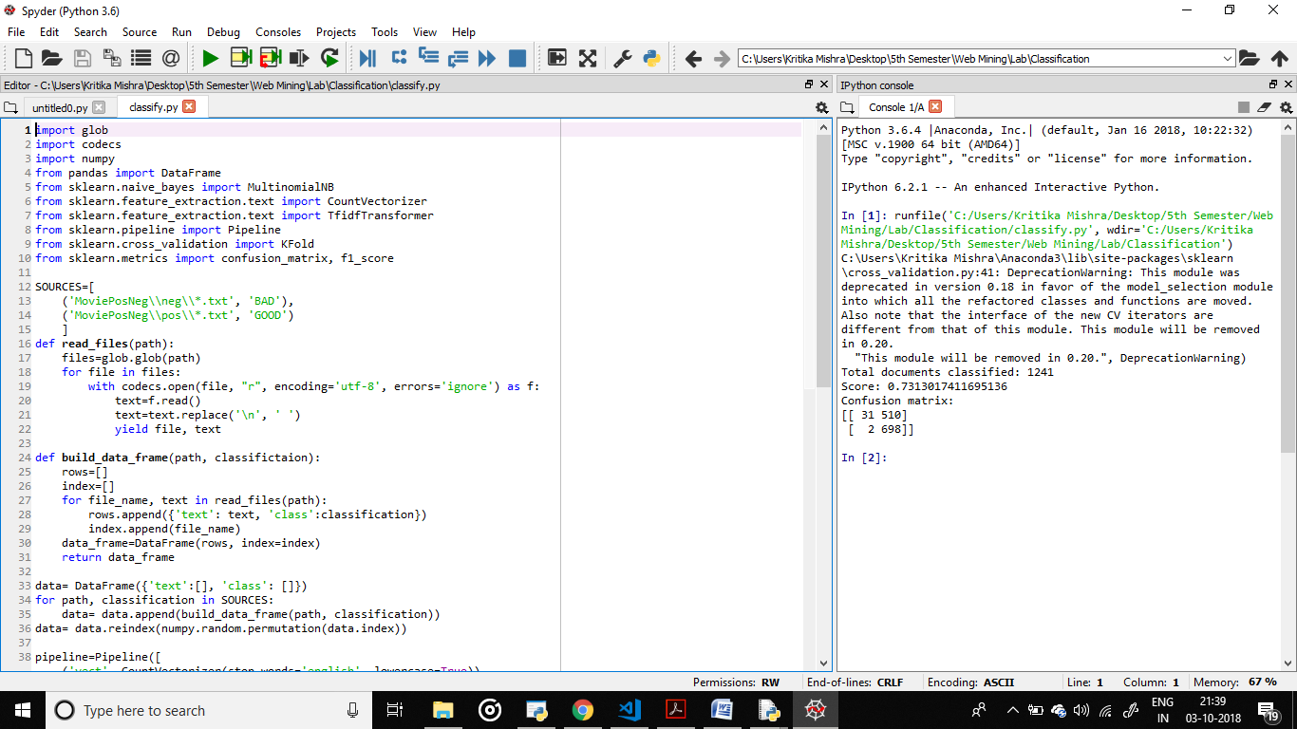

**Output:**

**Total documents classified: 1241**

**Score: 0.7313017411695136**

**Confusion matrix:**

**[[ 31 510]**

**[ 2 698]]**